**EXPERIMENT 11**

**PROCEDURES**

**Aim:**

* Create a table with attributes students and marks.
* Insert values into the table.
* Create a procedure to get the merit students (marks > 50).
* Create a procedure to get marks of a given id (using in).
* Create a procedure to display highest marks (using out).
* Create a procedure to get marks of a given id (using in and out).

**Code:**

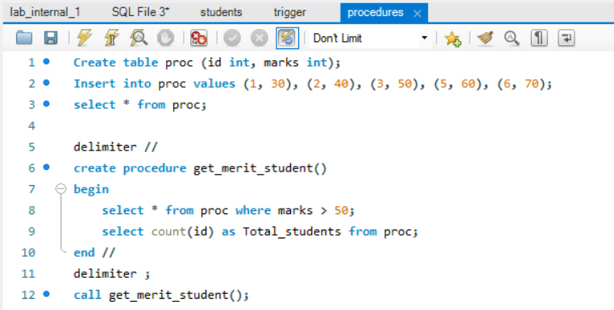

**Output:**

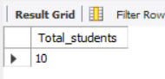

**Code:**

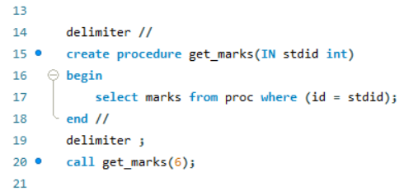

**Output:**

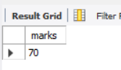

**Code:**

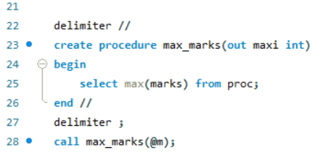

**Output:**

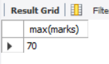

**Code:**

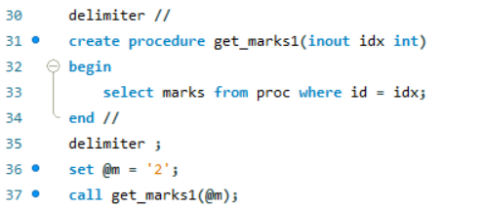

**Output:**

